Designing Efficient Parallel Algorithms on CRAP
Tzong-Wann Kao, Shi-Jinn Horng, Yue-Li Wang, and Horng-Ren Tsai
IEEE Transactions on Parallel and Distributed Systems, Vol. 6, No. 5, May 1995, pp.554-560
Abstract
A cross-bridge reconfigurable array of processors is a parallel processing system which has the ability to change dynamically the supported interconnection scheme during the execution of an algorithm.
Several O(1) time basic operations can be used to find the kth smallest element of N m bits unsigned integers in O(m) using N processors and to sort N data items in O(1) time using O(N^{5/3}) processors.
- Instruction
There are two minor differences between the CRAP with other existed reconfigurable parallel processing systems.
- The bus capacity between processors is assumed to be O(N^{1/c}) bits.
- Each processor has ten functions that can be used to establish a configuration of the bus system.
Fig.2 also shows five interesting configurations derivable from a processor in a 2-D CRAP.
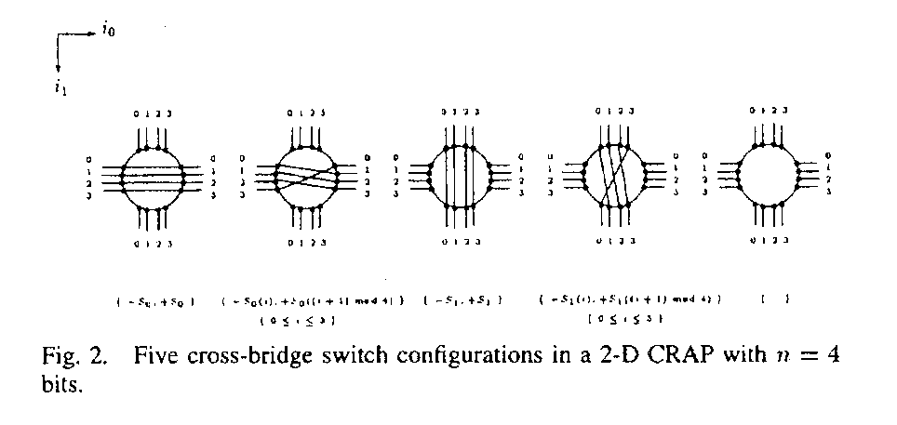
- Basic operations
  - Transpose and untranspose operations
  - Shift and unshift Operations.
  - Prefix sum of a binary sequence.
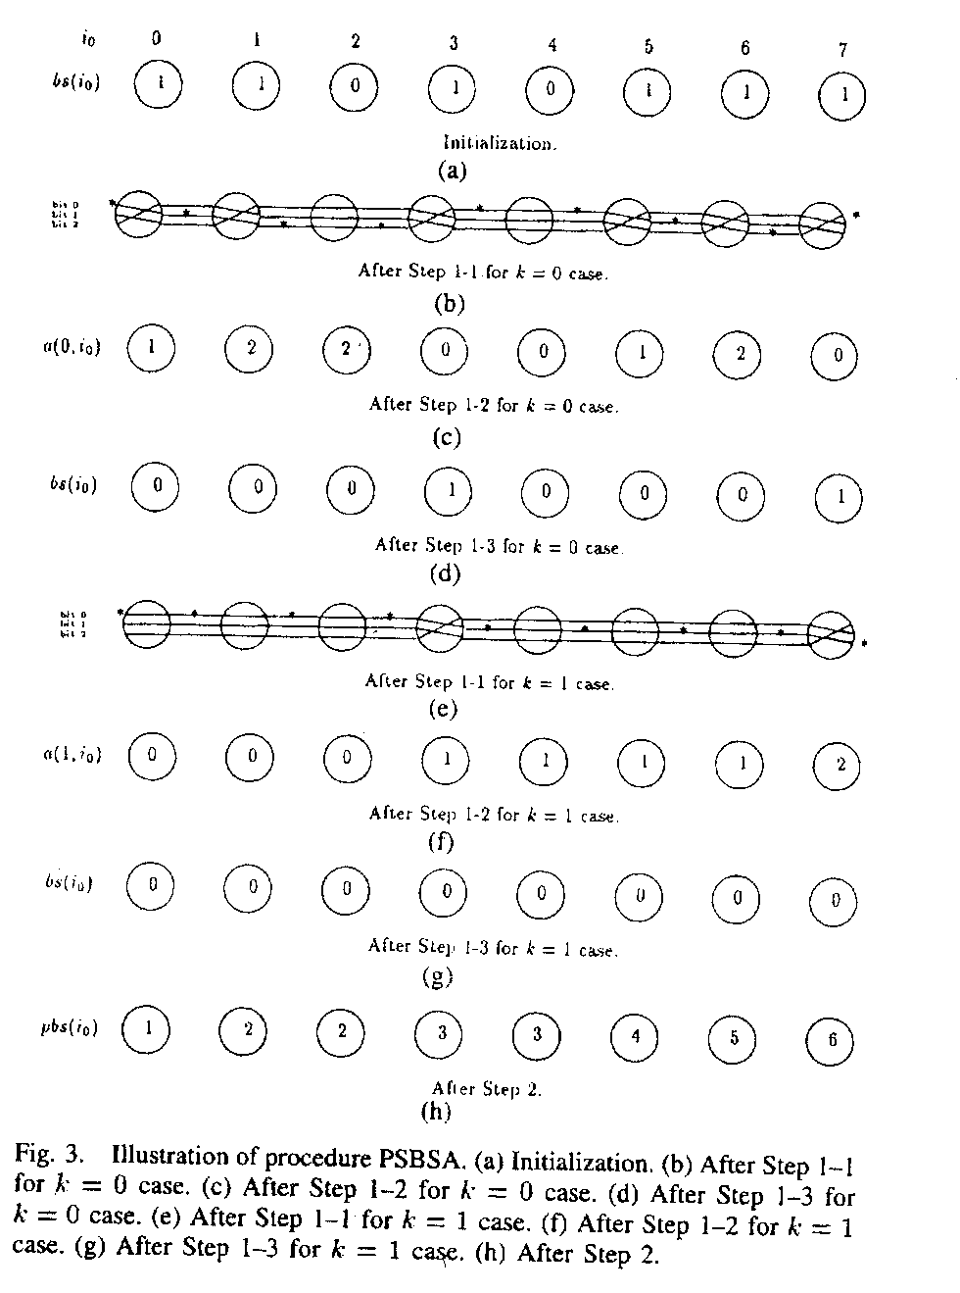
Corollary 1: Given a binary sequence sequence of length N, the prefix sum of these N binary data can be computed in O(1) time on a linear N CRAP with N^{1/c} bits bus width, where c is a constant and c≧1.
Corollary2: Given a binary sequence of length N, then finding the kth 1’s element of these N binary data can be computed in O(1) time on a linear N CRAP with N^{1/c} bits bus width, where c is a constant and c≧1.
- Applications
A. Parallel selection algorithm on a CRAP.
B. Sorting N data items on a CRAP.
Created by : Ming-Cheng Lin
Date : Feb 15, 2000

